**BACK-Admin-RESTful-edit-update**

---

**GET-edit(view) - !!!but with data selected card - !!!КОНТРОЛЛЕРЫ RESTful**

Verb Path Action Route Name

**GET /products/{product}/edit edit products.edit**

**Verb - метод передачи**

**Route Name — роут во вью**

**Action — имя метода в котроллере**

1.views/**back/brick-standard.blade.php** (href="{{ route('products.edit', [$product->id]) }}")

<td class="col-md-6 col-sm-6 col-xs-6 center widthbutton"><a class="btn btn-primary listbuttonupdate" **href="{{ route('products.edit', [$product->id]) }}"**><i class="fa fa-edit" aria-hidden="true"></i></a></td>

2.**AdminController.php**

use App\ {

Http\Controllers\Controller,

Repositories\AdminRepository,

Http\Requests\ProductRequest**,**

**Models\Product //!!!**

};

/**

* Show the form for editing the specified resource.

*

* @param \App\Models\Product $product

* @return \Illuminate\Http\Response

*/

public function **edit(Product $product) //!!!$product - RESTful-Controllers**

{

return view('back.products.**edit', compact('product')**); **//!!!$product - RESTful-Controllers**

}

3.views\back\**products\template.blade.php (for image and checkbox - @elseif(isset($product)){{asset('public/img/' . $product->image)}} + @if (\Request::is('products/create')) + @elseif(isset($product)){{$product->image)}} + @if(isset($product) && $product->top9 == 1){{'checked'}}@endif)**

<div class="form-group">

<**img** class="img_product" **src**="@if(isset($image)){{asset('public/img/bg-img/' . $image)}}@elseif(old('image')){{asset('public/img/' . old('image'))}}**@elseif(isset($product)){{asset('public/img/' . $product->image)}}**@else{{asset('public/img/bg-img/nophoto.jpg')}}@endif" alt="" style="width: 150px; margin-top: 5px;" />

**<!-- not updating image, only creating -->**

**@if (\Request::is('products/create'))**

<form method="post" action="{{ route('upload') }}" name="form_upload" enctype="multipart/form-data">

{{ csrf_field() }}

<input type="file" name="image" class="upload_field">

<button type="submit" class="upload_submit">Go</button>

<button type="button" class="btn btn-primary" style="width: 150px; margin-top: 5px;">Select</button>

</form>

**@endif**

...

<**input type="hidden"** id="image" **name="image"** value="@if(isset($image)){{'bg-img/' . $image}}@elseif(old('image')){{old('image')}}**@elseif(isset($product)){{$product->image}}**@else{{'bg-img/nophoto.jpg'}}@endif">

...

<input type="checkbox" id="top9" name="top9" **@if(isset($product) && $product->top9 == 1){{'checked'}}@endif** style="vertical-align: top;">

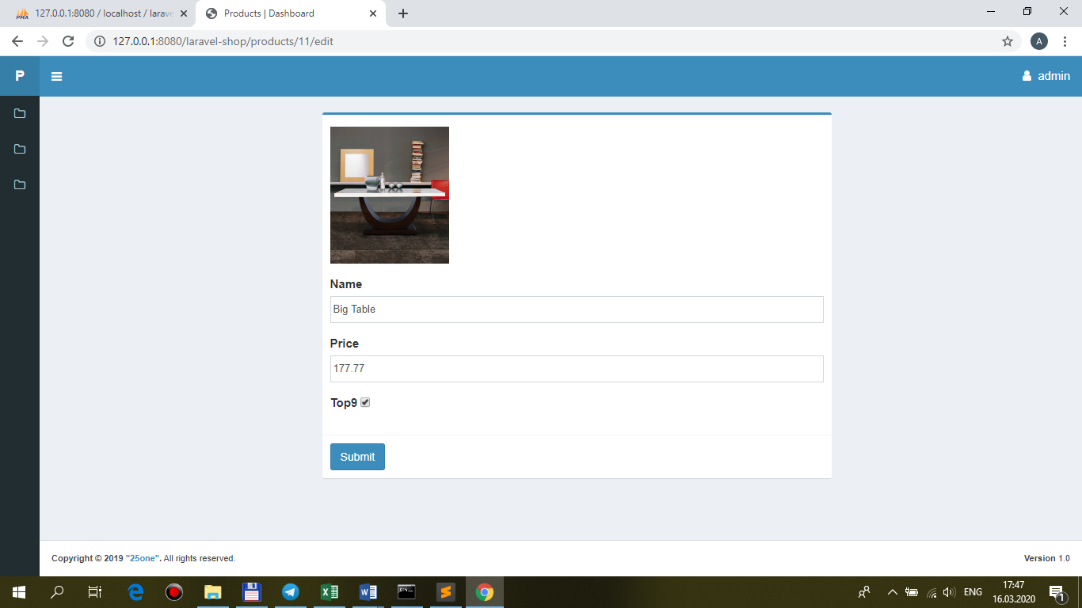

---

**PUT-update !!!but with data selected card - !!!КОНТРОЛЛЕРЫ RESTful**

Verb Path Action Route Name

**PUT /products/{product} update products.update**

**Verb - метод передачи**

**Route Name — роут во вью**

**Action — имя метода в котроллере**

Если у вас есть аналог **checkbox**-поля **top9** – для **корректировки** (из-за особенностей работы **checkbox**): **по-умолчанию 0**, т.к. **при выборе** есть **$request->top9 (on)**, при **не выборе** – просто нет **$request->top9 (null)**, теперь при **не выборе** будет **0**:

views\**back\products\template.blade.php**

<div class="form-group">

<label for="name">@lang('Top9')</label>

**<input name='top9' type='hidden' value='0'>**

<input type="checkbox" id="top9" name="top9" style="vertical-align: top;" @if(isset($product) && $product->top9 == 1){{'checked'}}@endif>

</div>

1.**AdminController.php**

/**

* Update the specified resource in storage.

*

* @param \App\Http\Requests\ProductRequest $request

* @param \App\Models\Product $product

* @return \Illuminate\Http\Response

*/

public function **update(ProductRequest $request, Product $product) //!!!$product - RESTful-Controllers**

{

**$this->repository->update($request, $product); //!!!$product - RESTful-Controllers**

**return redirect(route('dashboard'))->with('product-updated', 'Product has been successfully updated...');**

}

2.**AdminRepository.php**

/**

* Update product.

* @param \App\Models\Product $product

* @return void

*/

public function **update($request, $product)**

**{**

**$product->update($request->all());**

}

…**change Price (177.77 -> 77.77)**

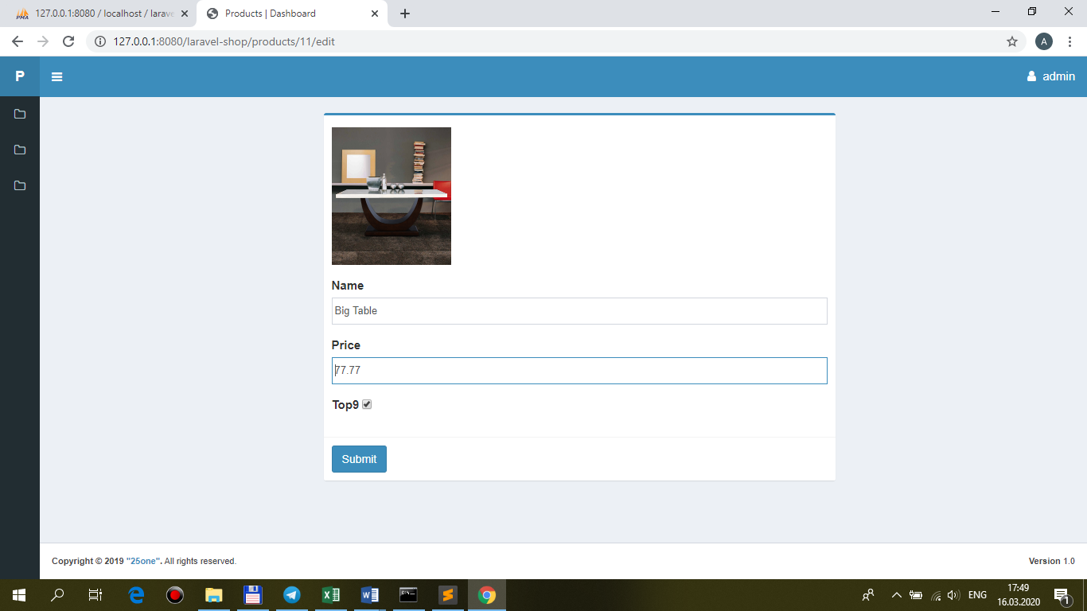

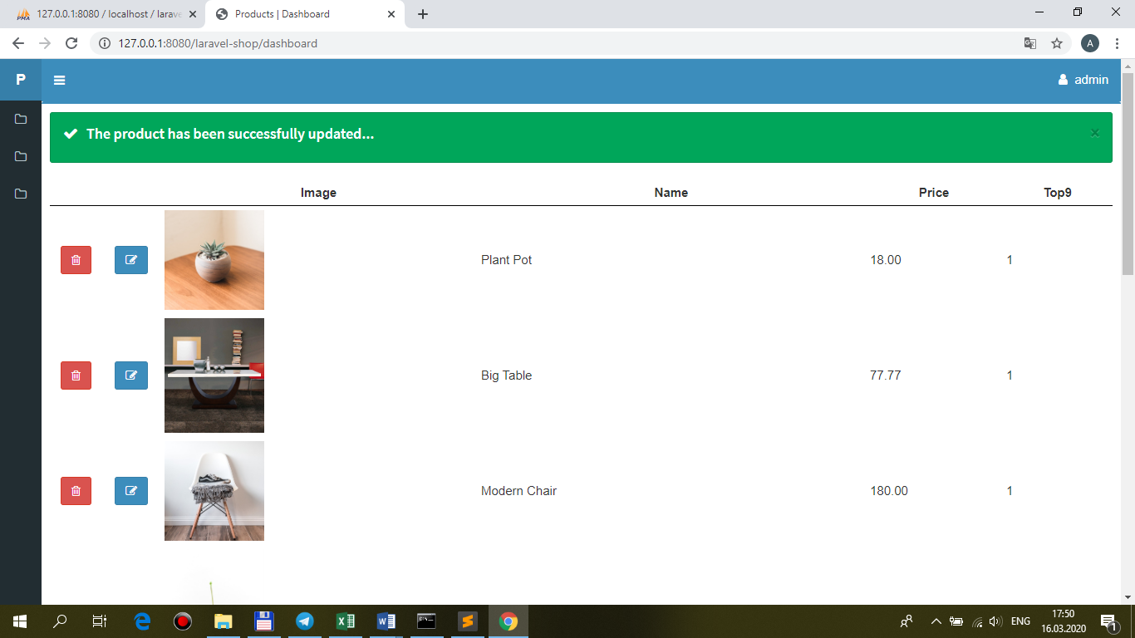

…**without Price**

